Staff list of D.El.Ed. Course in Private Teacher Education Institutions

Name of the Institution with address: G.B.R. ELEMENTARY TEACHER EDUCATION INSTITUTE, ANAPARTHI – 533342.

Name of the Society : Anaparthi Educational Society, Anaparthi
Sl.No | Name of the incumbent |  | Designation for which identified | Date of Birth & age | Community | Higher Educational |  |  | Methodology subjects in B.Ed. or equalent course with aggregate % | Teaching |  |  | Salary | Photo of incumbent with signatures
 |  |  |  |  |  | Teacher Education like M.Ed.,/M.A (Edn) with % of Marks | Mention School subject in PG with % marks |  |  | Teacher Education Institutions | School | Other
1 | 2 |  | 3 | 4 | 5 | 6 | 7 |  | 8 | 9 | 10 | 11 | 12 | 13
1 | Syamala Srinivasa Reddy |  | Principal | 10.06.1967 | OC | M.Ed  6.9  CGPA | M.A.  (Telugu)  68.3% |  | Social Studies & English  Telugu  (3rd Methodology) | 6 Years | ….. | …. | 12325-315-12955-600-24715 | 5  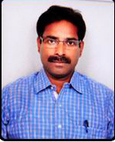7
2 | Sanyasi Rao Samireddi |  | Lecturer in Foundations of Education | 23.05.1975 | BC-D | M.Ed  58 | M.A (Psychology)  55% |  | Social Studies & English | 12 Years | ….. | …. | 10285-295-12010-525-21835 | 1  2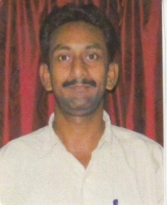  3  4  5  10
3 | Gumpalli Lakshmi Subbaiah |  | Lecturer in Foundations of Education | 01.07.1978 | OC | M.Ed  65 | M.A., (Philosophy)  55.7 |  | Mathematics & Physical Science | ….. | ….. | …. | 10285-295-12010-525-21835 | 1  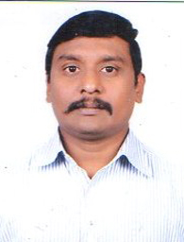4  5  8
4 | Mallolu Nageswara Rao | Lecturer in Foundations of Education |  | 14.02.1972 | BC-B | M.Ed  61 |  | M.A., (Philosophy)  57.12 | Social Studies & English | 1 Year | ….. | …. | 10285-295-12010-525-21835 | 1  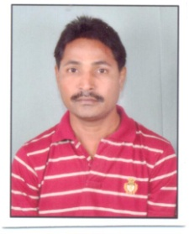2  10
5 | K Ravi Babu | Lecturer in Science |  | 20.06.1973 | OC | M.Ed  74 |  | M.Sc  (Chemistry)  58.5 | Mathematics & Physics | 6 Years | ….. | …. | 10285-295-12010-525-21835 | 1  4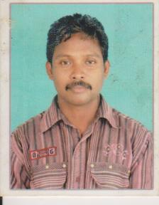  10
6 | Karri Manikyam | Lecturer in Science |  | 17.10.1985 | OC | M.Ed  75.3 |  | M.Sc (Organic Chemisty)  67.9 | Mathematics & Physics | ….. | …. | ….. | 10285-295-12010-525-21835 | 1  3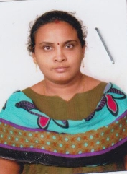
7 | Vemavarapu Messayya Das | Lecturer in Social Sciences |  | 05-04-1962 | SC | B.Ed  60.20 |  | M.A., Political Science  59 | English & Social | ….. | 11 Years | ….. | 10285-295-12010-525-21835 | 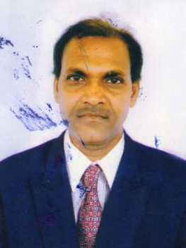
8 | Victor Emmanuel Meripo | Lecturer in Social Sciences |  | 16.08.1982 | BC-C | M.Ed  66.3 |  | M.A (Applied Economics)  62.8 | Social & Telugu | ….. | …. | ….. | 10285-295-12010-525-21835 | 1  2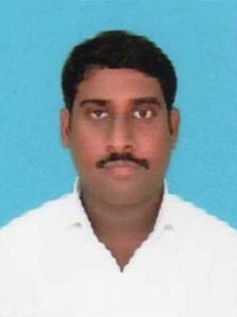  10
9 | P.V.S.S.S.R.K. Acharyulu | Lecturer in Mathematics |  | 15.06.1972 | OC | B.Ed  70.35 |  | M.Sc  (Maths)  62 | Mathematics & Physics | ….. | 13 Years | ….. | 10285-295-12010-525-21835 | 1  3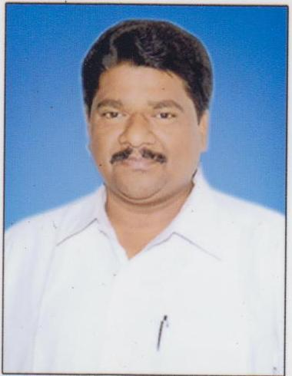
10 | Grandi Suresh | Lecturer in Mathematics |  | 16.03.1989 | OC | M.Ed  9  (CGPA) |  | M.Sc (Maths) 55.37 | Mathematics & Physics | ….. | ….. | …. | 10285-295-12010-525-21835 | 1  2  4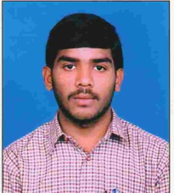
11 | M.S.V. Rama Mohan | Lecturer in English |  | 03.02.1970 | OC | M.Ed  8.4  (CGPA) |  | M.A (English) 60.9% | Social Studies & English | ….. | ….. | …. | 10285-295-12010-525-21835 | 13  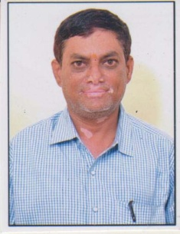
12 | Tarlampudi Chandra Rao | Lecturer in English |  | 15.07.1987 | SC | M.Ed  7.8  (CGPA) |  | M.A (English) 51.9% | Social Studies & English | ….. | ….. | …. | 10285-295-12010-525-21835 | 1  4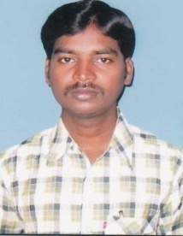
13 | Bhavani Varre | Lecturer in Telugu |  | 06.06.1985 | BC-D | M.Ed  7  (CGPA) |  | M.A (Telugu)  55% | Mathematics & Telugu | ….. | ….. | …. | 10285-295-12010-525-21835 | 1  2  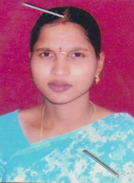3  4
14 | Bade Venkateswara Rao | Lecturer in Fine Arts |  | 11.08.1981 | OC | M.P.A  77.3 |  | ….. | ….. | 6 Years | ….. | …. | 10285-295-12010-525-21835 | 15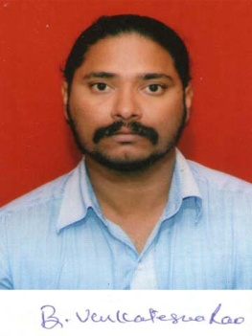  10
15 | Srinivasa vara Prasad Pati | Lecturer in Performing Arts |  | 05.06.1986 | OC | M.P.A.,  (Kuchipudi)  59.5 |  | ….. | ….. | ….. | ….. | …. | 10285-295-12010-525-21835 | 12  6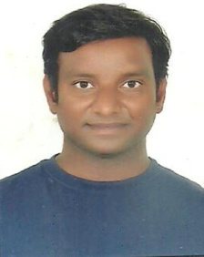
16 | Rajupadal Kankipati | Lecturer in Physical Education |  | 01.06.1984 | ST | M.P.Ed  7.1  (CGPA) |  | ….. | ….. | ….. | ….. | …. | 10285-295-12010-525-21835 | 14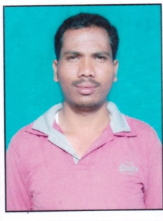  60

